Sardar Patel Institute of Technology, Mumbai

Department of Electronics and Telecommunication Engineering

B.E. Sem-VII- PE-IV (2024-2025)

**IT 24 - AI in Healthcare**

**Experiment 6: Healthcare data analysis in unsupervised learning**

**(K Means Clustering) using R Programming**

**Name:**  Adwait Purao **Date: 14**/10/2024

**Objective:**

To learn the basics of R programming and RStudio IDE and apply it in healthcare dataset in un-supervised learning algorithm (K Means Clustering), Interpret and visualize Clustering results.

**Dataset:** <https://www.kaggle.com/datasets/iamhungundji/covid19-symptoms-checker>

The dataset is designed to help identify individuals with coronavirus disease based on defined symptoms aligned with WHO guidelines. It features seven key variables: Country, Age, Symptoms (Fever, Tiredness, Difficulty in breathing, Dry cough, Sore throat), Other Symptoms (Pains, Nasal Congestion, Runny Nose, Diarrhea, Other), Severity (Mild, Moderate, Severe), and Contact with COVID-19 patients. A total of 316,800 combinations of these categorical variables are generated.

There are two CSV files: Raw-Data, which lists all possible variable combinations, and Cleaned-Data, which contains the processed combinations for analysis, including dummy variables. Potential applications of this data include developing a chatbot, and conducting supervised learning (classification) and unsupervised learning (clustering). Future plans involve incorporating more WHO guidelines for expanded data and exploring reinforcement learning techniques.

We are using Cleaned data file as covid_symptoms.csv.

**Theory:**

**K-means Clustering in Healthcare AI/ML**

K-means clustering is an unsupervised learning algorithm commonly used in healthcare for various applications.

**Basic Concept**

K-means partitions n observations into k clusters, where each observation belongs to the cluster with the nearest mean (centroid).

**Algorithm Steps**

1. Choose k initial centroids
2. Assign each data point to the nearest centroid
3. Recalculate centroids based on assigned points
4. Repeat steps 2-3 until convergence

**Applications in Healthcare**

* Patient Segmentation
* Disease Subtyping
* Medical Image Analysis
* Drug Discovery

**Example: Patient Segmentation**

Input: Patient data (age, BMI, blood pressure, etc.)

Output: k patient clusters

1. Initialize k centroids randomly

2. Assign patients to nearest centroid based on their features

3. Update centroids as mean of assigned patients

4. Repeat 2-3 until stable

**Advantages**

* Simplicity and scalability
* Useful for discovering hidden patterns in medical data

**Limitations**

* Requires predefined k
* Sensitive to initial centroid selection
* Assumes spherical clusters

**Experiment (Steps):**

1. Install R and RStudio.

2. Install packages tidyverse, ggplot2, and dplyr.

3. Import a healthcare dataset

4. Load the Dataset

5. Data pre-processing

6. Choose the Number of Clusters(Using Elbow Method

7. Apply K-Means Clustering

8. Segment patients into risk groups

9. Interpret and visualize the Clusters

**Code & Output:**

install.packages(c("tidyverse", "ggplot2", "dplyr", "factoextra"))  
library(tidyverse)  
library(ggplot2)  
library(dplyr)  
library(factoextra)

Installing packages into ‘/usr/local/lib/R/site-library’  
(as ‘lib’ is unspecified)  
  
── Attaching core tidyverse packages ──────────────────────── tidyverse 2.0.0 ──  
✔ dplyr 1.1.4 ✔ readr 2.1.5  
✔ forcats 1.0.0 ✔ stringr 1.5.1  
✔ ggplot2 3.5.1 ✔ tibble 3.2.1  
✔ lubridate 1.9.3 ✔ tidyr 1.3.1  
✔ purrr 1.0.2   
── Conflicts ────────────────────────────────────────── tidyverse_conflicts() ──  
✖ dplyr::filter() masks stats::filter()  
✖ dplyr::lag() masks stats::lag()  
ℹ Use the conflicted package (<http://conflicted.r-lib.org/>) to force all conflicts to become errors  
Welcome! Want to learn more? See two factoextra-related books at https://goo.gl/ve3WBa

covid_data <- read.csv("covid_symptoms.csv")  
head(covid_data)

Fever Tiredness Dry.Cough Difficulty.in.Breathing Sore.Throat None_Sympton  
1 1 1 1 1 1 0   
2 1 1 1 1 1 0   
3 1 1 1 1 1 0   
4 1 1 1 1 1 0   
5 1 1 1 1 1 0   
6 1 1 1 1 1 0   
 Pains Nasal.Congestion Runny.Nose Diarrhea ⋯ Gender_Male Gender_Transgender  
1 1 1 1 1 ⋯ 1 0   
2 1 1 1 1 ⋯ 1 0   
3 1 1 1 1 ⋯ 1 0   
4 1 1 1 1 ⋯ 1 0   
5 1 1 1 1 ⋯ 1 0   
6 1 1 1 1 ⋯ 1 0   
 Severity_Mild Severity_Moderate Severity_None Severity_Severe  
1 1 0 0 0   
2 1 0 0 0   
3 1 0 0 0   
4 0 1 0 0   
5 0 1 0 0   
6 0 1 0 0   
 Contact_Dont.Know Contact_No Contact_Yes Country  
1 0 0 1 China   
2 0 1 0 China   
3 1 0 0 China   
4 0 0 1 China   
5 0 1 0 China   
6 1 0 0 China

# Select relevant features for clustering  
features <- covid_data %>%  
 select(Fever, Tiredness, `Dry.Cough`, `Difficulty.in.Breathing`,  
 `Sore.Throat`, Pains, `Nasal.Congestion`, `Runny.Nose`, Diarrhea)  
  
# Normalize the data  
features_normalized <- scale(features)

library(parallel)  
library(factoextra)  
  
# Function to compute WSS for a given k  
compute_wss <- function(k) {  
 kmeans(features_normalized, centers = k, nstart = 25, iter.max = 100, algorithm = "Lloyd")$tot.withinss  
}  
  
# Compute WSS for k = 1 to 8 in parallel  
k_range <- 1:8  
num_cores <- detectCores() - 1 # Use all cores except one  
wss <- mclapply(k_range, compute_wss, mc.cores = num_cores)  
  
# Convert the result to a numeric vector  
wss <- unlist(wss)  
  
# Create a data frame for ggplot  
elbow_data <- data.frame(k = k_range, wss = wss)

# Plot the elbow curve using ggplot2  
elbow_plot <- ggplot(elbow_data, aes(x = k, y = wss)) +  
 geom_line() +  
 geom_point() +  
 labs(x = "Number of clusters (k)",  
 y = "Total within-cluster sum of squares",  
 title = "Elbow Method for Optimal k",  
 subtitle = "Optimal k is where the elbow bends") +  
 theme_minimal()  
  
print(elbow_plot)

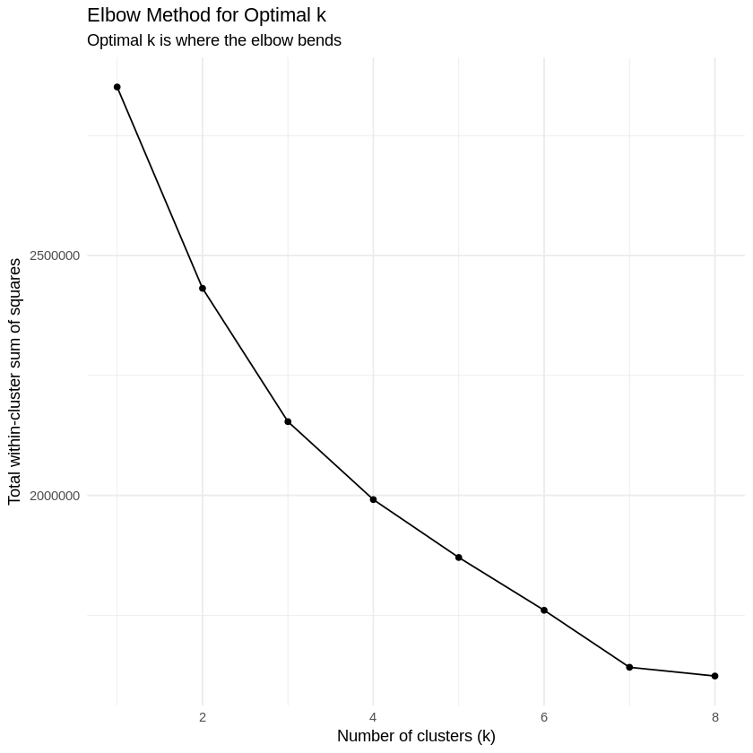

Clearly k should be 3 here

# Apply K-Means Clustering  
set.seed(123) # for reproducibility  
k <- 3  
kmeans_result <- kmeans(features_normalized, centers = k, nstart = 25, iter.max = 100, algorithm = "Lloyd")

# Add cluster assignments to the original dataset  
covid_data$Cluster <- as.factor(kmeans_result$cluster)  
  
# Segment patients into risk groups  
cluster_means <- features_normalized %>%  
 as.data.frame() %>%  
 mutate(Cluster = kmeans_result$cluster) %>%  
 group_by(Cluster) %>%  
 summarise(across(everything(), mean)) %>%  
 ungroup()

# Assign risk levels based on symptom severity  
risk_scores <- rowSums(cluster_means[,-1])  
risk_levels <- c("Low", "Moderate", "High") # Adjust risk levels to match k=3  
cluster_risk <- data.frame(Cluster = as.factor(1:k), # Convert Cluster to factor  
 Risk = risk_levels[rank(risk_scores)])

# Join the data  
covid_data <- covid_data %>%  
 left_join(cluster_risk, by = "Cluster")

# Quick summary of risk distribution  
risk_summary <- table(covid_data$Risk)  
print(risk_summary)

High Low Moderate   
 79200 138600 99000

risk_summary_prop <- prop.table(table(covid_data$Risk))  
print(risk_summary_prop)

High Low Moderate   
 0.2500 0.4375 0.3125

install.packages(c("ggforce"))

Installing package into ‘/usr/local/lib/R/site-library’  
(as ‘lib’ is unspecified)  
  
also installing the dependencies ‘tweenr’, ‘polyclip’

library(ggrepel)  
library(ggforce)  
  
# Visualize clusters using PCA  
pca_result <- prcomp(features_normalized, center = FALSE, scale. = FALSE)  
pca_data <- as.data.frame(pca_result$x[,1:2])  
pca_data$Cluster <- covid_data$Cluster  
pca_data$Risk <- covid_data$Risk

# Plot PCA results with improvements  
pca_plot <- ggplot(pca_data, aes(x = PC1, y = PC2, color = Risk)) +  
 geom_jitter(alpha = 0.7, size = 2, width = 0.1, height = 0.1) +  
 stat_ellipse(aes(fill = Risk), type = "norm", level = 0.95, geom = "polygon", alpha = 0.2) +  
 labs(title = "COVID-19 Symptom Clusters",  
 x = "Principal Component 1",  
 y = "Principal Component 2") +  
 theme_minimal() +  
 theme(  
 plot.title = element_text(face = "bold", size = 16),  
 axis.title = element_text(face = "bold", size = 12),  
 legend.title = element_text(face = "bold"),  
 panel.grid.major = element_line(color = "gray90"),  
 panel.grid.minor = element_line(color = "gray95")  
 ) +  
 scale_color_brewer(palette = "Dark2") +  
 scale_fill_brewer(palette = "Dark2") +  
 coord_fixed(ratio = 1)  
  
print(pca_plot)

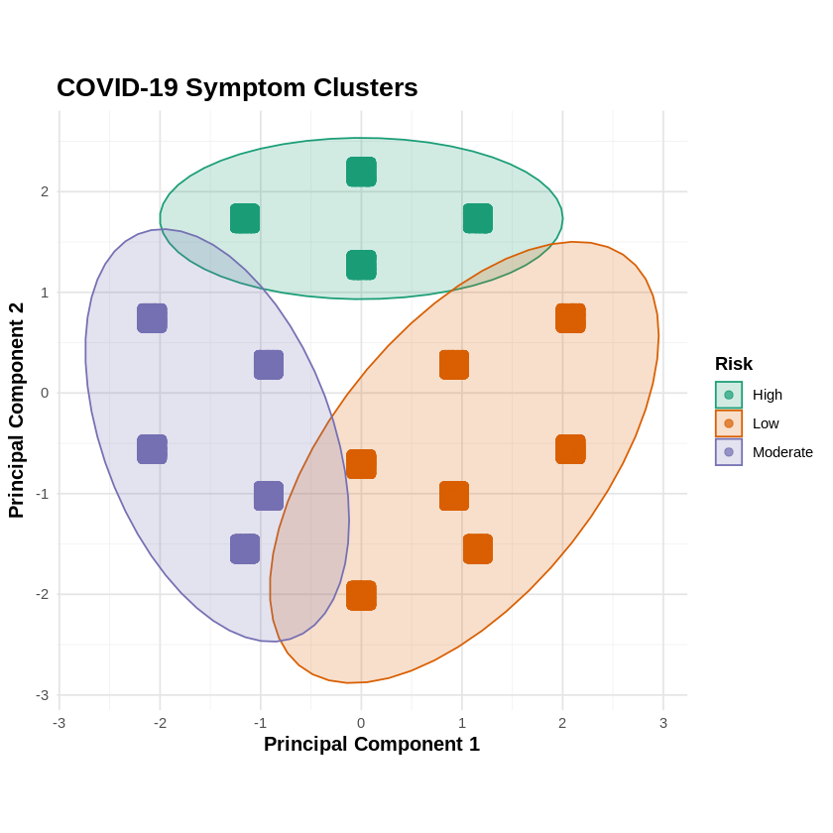

library(forcats)

# Prepare the data  
cluster_centers <- as.data.frame(kmeans_result$centers)  
cluster_centers$Cluster <- as.factor(1:k)  
  
cluster_centers_long <- cluster_centers %>%  
 pivot_longer(cols = -Cluster, names_to = "Symptom", values_to = "Value") %>%  
 mutate(Symptom = fct_reorder(Symptom, Value)) # Reorder symptoms by overall importance

# Calculate overall importance for each symptom  
symptom_importance <- cluster_centers_long %>%  
 group_by(Symptom) %>%  
 summarize(OverallImportance = mean(abs(Value))) %>%  
 arrange(desc(OverallImportance))

# Order symptoms by overall importance  
cluster_centers_long$Symptom <- factor(cluster_centers_long$Symptom,  
 levels = symptom_importance$Symptom)

# Create the enhanced plot  
feature_importance_plot <- ggplot(cluster_centers_long, aes(x = Symptom, y = Value, fill = Cluster)) +  
 geom_bar(stat = "identity", position = position_dodge(width = 0.9), width = 0.8) +  
 geom_hline(yintercept = 0, linetype = "dashed", color = "gray50") +  
 coord_flip() + # Flip coordinates for horizontal bars  
 facet_wrap(~ Cluster, nrow = 1) + # Separate plot for each cluster  
 labs(title = "Feature Importance by Cluster",  
 subtitle = "Normalized values of symptoms for each cluster",  
 x = "Symptoms",  
 y = "Normalized Value",  
 fill = "Risk Level") +  
 theme_minimal(base_size = 12) +  
 theme(  
 plot.title = element_text(face = "bold", size = 16),  
 plot.subtitle = element_text(size = 12, color = "gray30"),  
 axis.title = element_text(face = "bold"),  
 axis.text.y = element_text(size = 10),  
 legend.position = "top",  
 panel.grid.major.y = element_blank(),  
 panel.grid.minor.y = element_blank(),  
 strip.text = element_text(face = "bold")  
 ) +  
 scale_fill_brewer(palette = "Set2") +  
 scale_y_continuous(limits = c(-1, 1), breaks = seq(-1, 1, 0.5))  
  
print(feature_importance_plot)

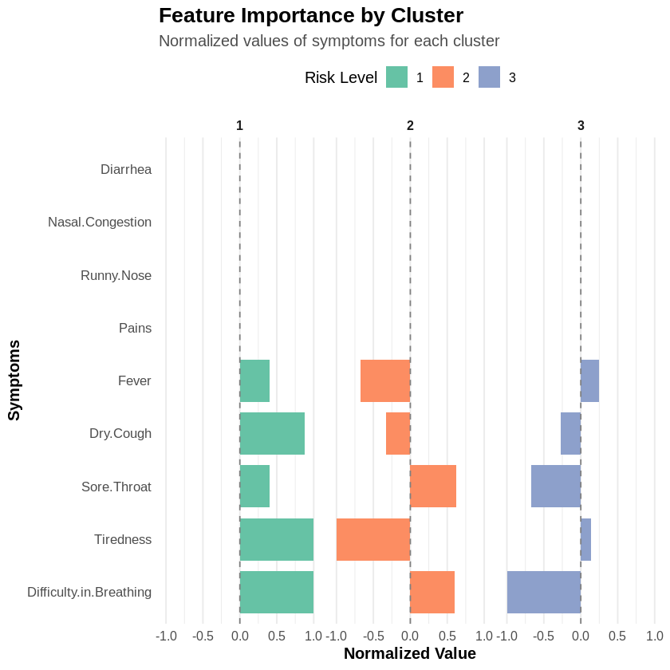

**Conclusion:**

From this experiment, I successfully segmented patients into three distinct risk groups—Low, Moderate, and High—using K-means clustering on the COVID-19 symptoms dataset.

The optimal number of clusters (k=3) was determined through the Elbow Method, and key features such as fever, tiredness, dry cough, and breathing difficulty were selected for clustering.

The results highlighted clear patient segmentation based on symptom severity. The final PCA visualization demonstrated distinct clusters, offering valuable insights for healthcare applications, such as patient segmentation and risk assessment.